**Oracle DB Monitoring**

Link => <https://github.dxc.com/pages/Innovation-Automation/dynatrace_documentation/user_guides/monitoring/database_monitoring/ORACLE/Oracle%20DB%20Deployment/>

1. Search for extenions
2. 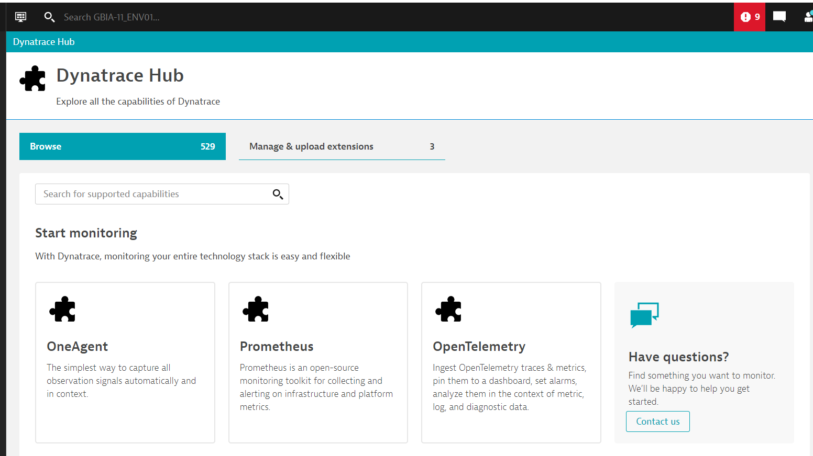
3. Search for Oracle database
4. 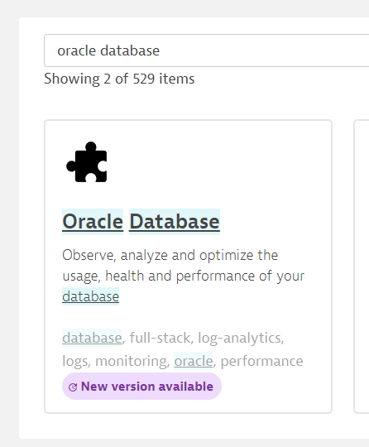
5. Add this to your monitoring configuration